Auto Cloth Fixer 1.0
Step-by-Step User Manual
MobileFunExplorer
For Unity Editor
What this tool is for: Auto Cloth Fixer helps you repair clothing poke-through, make quick manual shape adjustments, and save new clothing or body mesh variants directly from the Unity Editor. It is designed for fast cleanup, not for full character modeling.
Best use cases: shirts, tunics, jackets, dresses, pants, boots, sleeves, shoulders, chest, arms, hips, thighs, knees, and other areas where clothing intersects the body during posing or animation.
Recommended positioning for release: promote it as a fast repair and sculpt workflow for clothing and body adjustment inside Unity. Treat full automation as a helper, and manual control as the main strength of the tool.

1. Quick Start
- Select the character in your scene and open the Clothing Repair window.
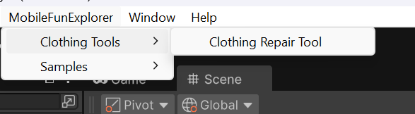
- Assign the Clothing Mesh and the Body Mesh.
- 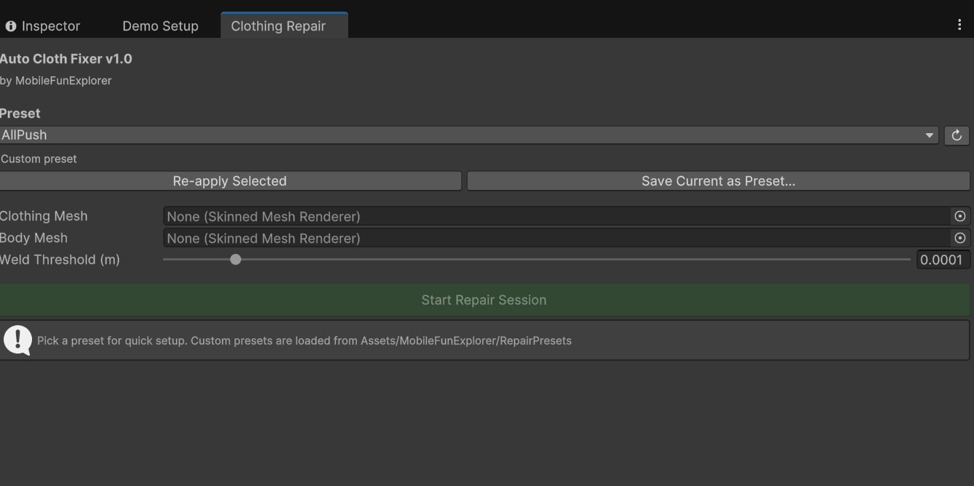
- Choose a preset or keep the current values.
- Click Re-apply Pose if needed so the tool reads the current pose correctly.
- Use Preview Penetrations to inspect the problem areas.
- Run Auto Push-Out for a first cleanup pass.
- Use the Manual Sculpt Brush to refine the result on Clothing or Body.
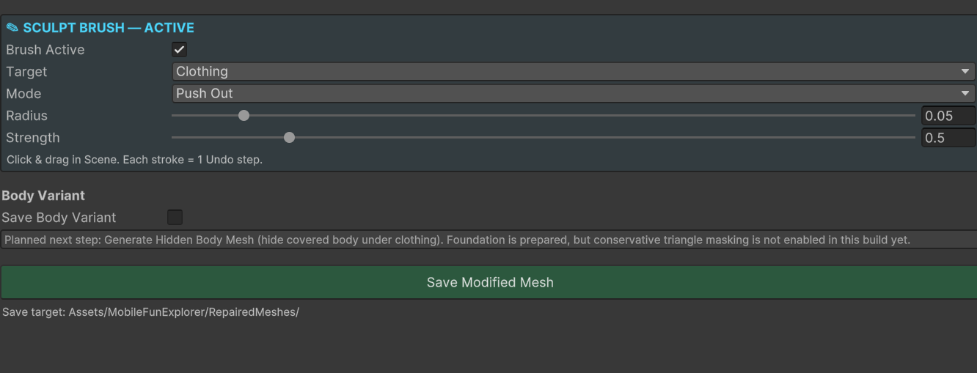
- Click Save Modified Mesh to create a repaired mesh asset.

2. Before You Start
- Work on a character that already has valid skinning and a usable pose.
- Use a Clothing Mesh as the editable mesh and a Body Mesh as the collision reference.
- For best results, use one clothing piece at a time.
- Make a backup of important meshes before large edits.
- After changing the pose, refresh the tool state before repairing again.

3. Window Overview
- Preset: Load a ready-made profile for common cases such as tight shirts, dresses, pants, or boots.
- Clothing Mesh / Body Mesh: Choose the skinned mesh renderer you want to edit and the body used for collision and comparison.
- Visualization: Shows body and border data so you can better understand where the tool is working.
- Border Protection: Helps protect edges such as collars, cuffs, hems, sleeve ends, and other visible clothing borders.
- Detection: Controls how strict the tool is when identifying true penetrations.
- Push Settings: Controls offset, range, iterations, and smoothing for automatic repair.
- Manual Sculpt Brush: Lets you manually push, pull, inflate, deflate, or smooth the Clothing or Body mesh.
- Body Variant: When body editing is used, the tool can save a separate body variant along with the clothing result.
- Save Modified Mesh: Creates the final repaired asset in your chosen output folder.

4. Basic Workflow: Fast Clothing Repair
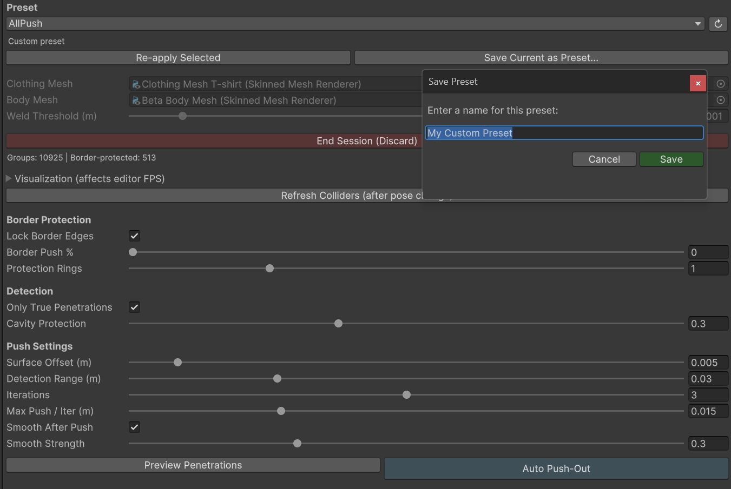
- Step 1 - Assign the meshes: Drag the clothing renderer into Clothing Mesh and the underlying character body renderer into Body Mesh.
- Step 2 - Load or choose a preset: Start with a preset close to your use case. Tight tops need different values than loose coats or boots.
- Step 3 - Re-apply Pose: Use this after changing animation, pose, or mesh state so the tool rebuilds its working data.
- Step 4 - Preview the issue: Use Preview Penetrations to inspect where the clothing intersects the body.
- Step 5 - Run Auto Push-Out: Use Auto Push-Out to perform the first repair pass. This is best for broad cleanup.
- Step 6 - Inspect the silhouette: Rotate around the model and check shoulders, armpits, chest, waist, hips, elbows, knees, and boots.
- Step 7 - Refine manually: If some areas still need work, switch to the Manual Sculpt Brush.
- Step 8 - Save the repaired mesh: Click Save Modified Mesh. A new repaired asset is created without replacing your original source mesh.

5. Manual Sculpt Workflow: Clothing
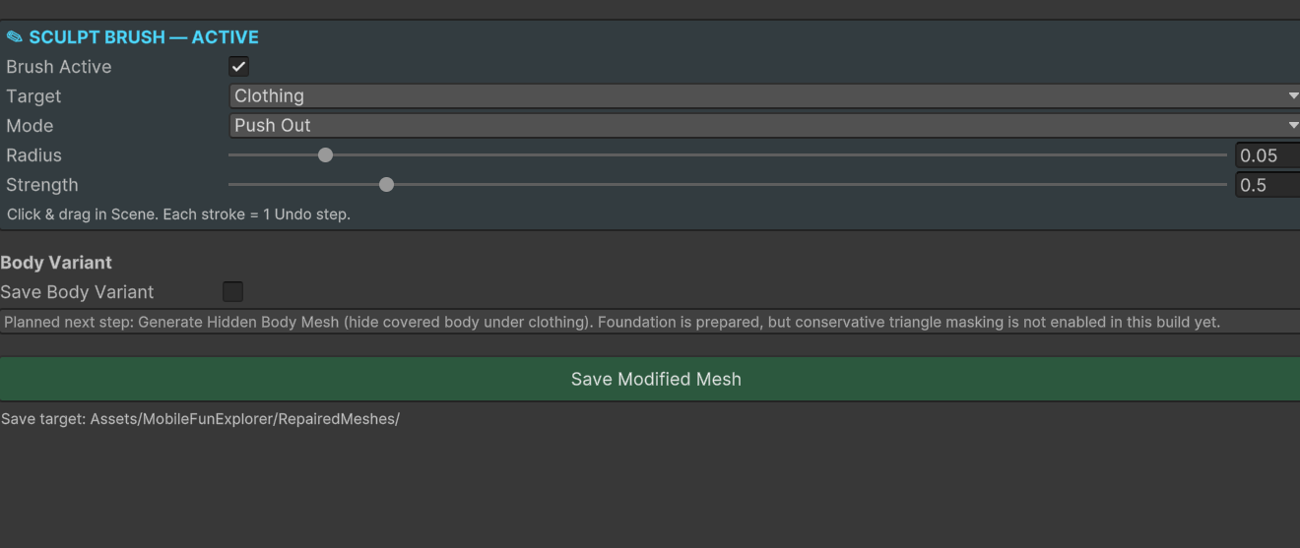
- Enable Brush Active.
- Set Target to Clothing.
- Choose a brush mode such as Push Out, Push In, Inflate, Deflate, or Smooth, depending on your build.
- Adjust Radius for the size of the area you want to edit.
- Adjust Strength for softer or stronger changes.
- Brush gradually over the problem area instead of doing one strong stroke.
- Use Smooth after larger edits to reduce harsh transitions.
- Inspect the result from several angles before saving.
Tip: For collars, sleeve ends, hems, and visible silhouettes, manual cloth sculpt is usually safer than pushing automatic settings too far.

6. Manual Sculpt Workflow: Body
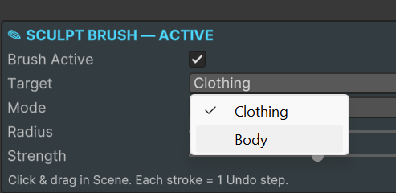
- Enable Brush Active.
- Set Target to Body.
- Use a gentle radius and low-to-medium strength first.
- Shrink or deflate the body slightly only where the clothing needs more clearance.
- Use very small edits on neck, wrists, shoulders, chest, hips, and thighs.
- Avoid aggressive body changes unless you intentionally want to alter shape.
- Save when the clothing has enough clearance and the body still looks natural under other outfits.
Important: When body editing is used, save a body variant rather than assuming the original body should be overwritten.

7. Recommended Workflow
- Auto pass first.
- Manual cloth cleanup second.
- Manual body adjustment only when needed.
- Save a repaired clothing mesh every time.
- Save a body variant only when body edits were made.

8. Best Practices
- If are less areas use manually.
- Treat automation as a starting point, not the final answer in every case.
- Protect clothing borders with conservative settings.
- Work on one outfit element at a time.
- Use body editing only where the clothing truly needs extra space.
- Check the result in the exact poses or animations where clipping was visible.
- Save multiple versions while testing presets or sculpt changes.

9. Troubleshooting
- Nothing seems to happen: Make sure the correct clothing and body renderers are assigned, then re-apply pose and try Preview Penetrations again.
- The result is too weak: Increase Surface Offset, Detection Range, or Iterations slightly, then refine with manual brush.
- The result looks too inflated: Lower offset or strength, then use Smooth or a smaller manual brush pass.
- Collars or cuffs get damaged: Use stronger border protection and do manual edits instead of pushing automatic values too far.
- Body shape changed too much: Use a lower brush strength on Body and keep body edits local.
- A saved result is hard to compare: Turn off the clothing temporarily or compare the new mesh against the original in the same pose.

10. Limitations
This tool is not a replacement for full modeling, retopology, or rigging cleanup. It works best as a fast repair and sculpt utility inside Unity. Extremely loose clothing, badly skinned meshes, broken normals, or very complex overlap cases may still require manual cleanup or source edits outside Unity.

11. Quick FAQ
- Does it replace my original mesh? No. The intended workflow is to save a new repaired mesh asset.
- Can I use it only manually? Yes. Manual brush editing is a core use case, not just a fallback.
- Can I adjust the body too? Yes. Body sculpting can be used for local clearance and shape refinement.
- Is the automatic pass always enough? Not always. The best workflow is usually auto first, manual second.

12. Recommended Quick Start Text for Package Users
- 1. Assign Clothing Mesh and Body Mesh.
- 2. Load a preset or keep default settings.
- 3. Re-apply Pose.
- 4. Preview Penetrations.
- 5. Run Auto Push-Out.
- 6. Refine with Manual Sculpt Brush on Clothing or Body.
- 7. Save Modified Mesh.

